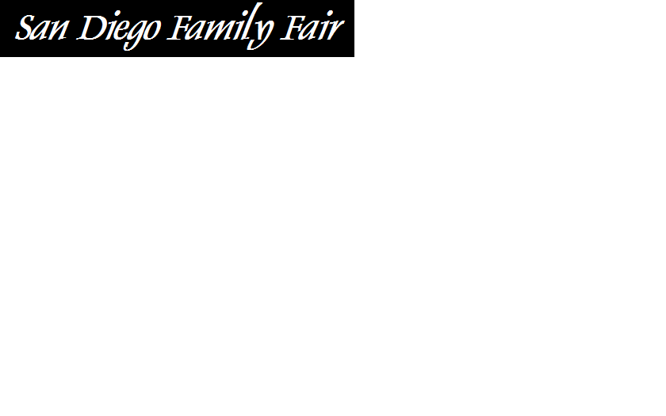






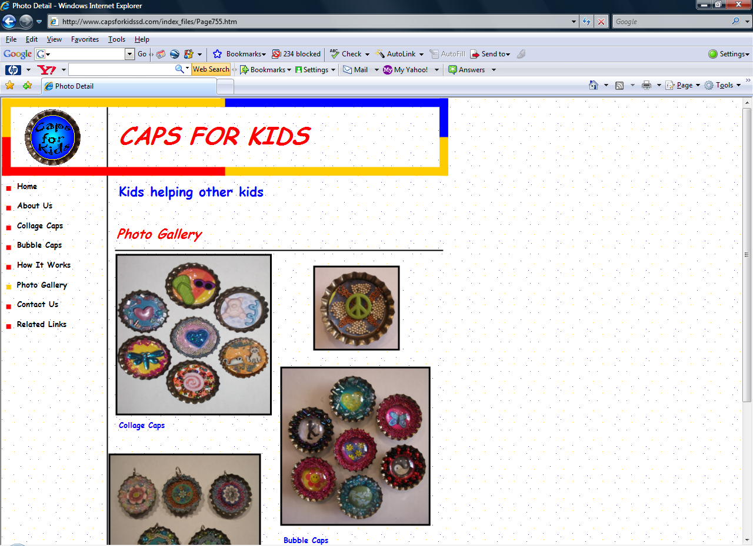













INCLUDEPICTURE "http://www.californiamoves.com/images/Navigation/cbrb_logo.gif" \* MERGEFORMATINET
Jeannine LaChance
www.VerticalPrinting.com (760) 334-2004
INCLUDEPICTURE "http://www.melaleuca.com/ps/images_us/splash_logo.gif" \* MERGEFORMATINET
Friends With Class is Turning One – we will have birthday cake for all

Budget
$ense

INCLUDEPICTURE "http://www.arbonne.com/images/common_graphics/topnav/newArbonneLogo_eng.gif" \* MERGEFORMATINET
San Diego’s Most Unique Catalog of Classes & Events!
The Bernardo Winery is located at 13330 Paseo Del Verano North - San Diego 92128 (exit Rancho Bernardo Rd off the 15 freeway and head east, turn left on Pomerado and right on Paseo del Verano, drive up the hill until you hit the winery). Admission to the fair is FREE, parking and entertainment included.
INCLUDEPICTURE "http://www.partylite.us/images/logo.gif" \* MERGEFORMATINET

Sunday, October 5th at the Bernardo Winery
10 am to 1 pm: Free music, jumper, admission & parking

100% of proceeds benefit Habitat for Humanity, who break ground
on their 100th SD home. Let’s gather 100+ families to celebrate!

Friends With Class and other mom-run / family-friendly businesses invite you to the
second annual San Diego Family Fair, featuring a free jumper and $5 pony rides for the kids provided by
Party Ponies Express, delicious food and wine tasting for the adults and live music from

"PATTY HALL'S JUMPIN' UP! SONGS"
and the amazing “SEMISI & FULA BULA”
to be enjoyed as you browse tables featuring beautiful jewelry, crafts, gift ideas and unique services.
You can also win over 20 raffle items, each at least $50 in value to benefit Habitat for Humanity.

